**Exercise 7: Packages**

Scenario 1: Group all customer-related procedures and functions into a package.

**PL/SQL Code:**

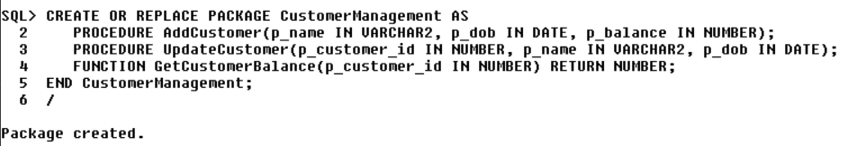

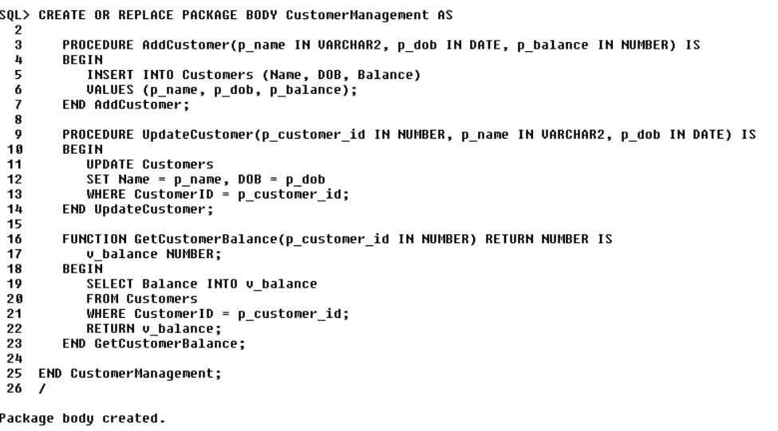

**Output:**

* AddCustomer()

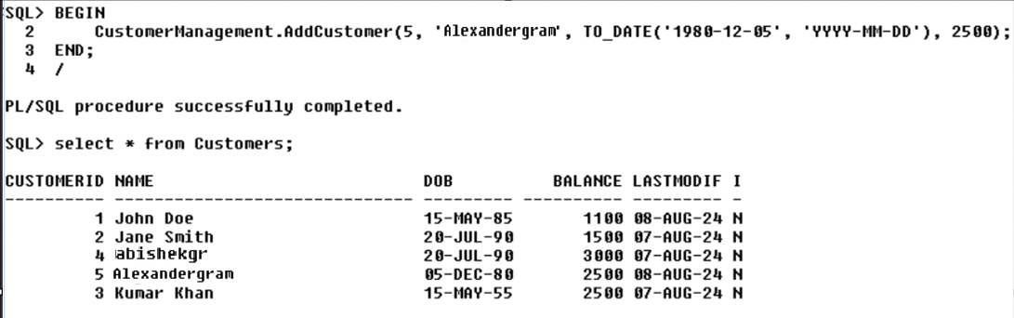

* UpdateCustomer()



* GetCustomerBalance()

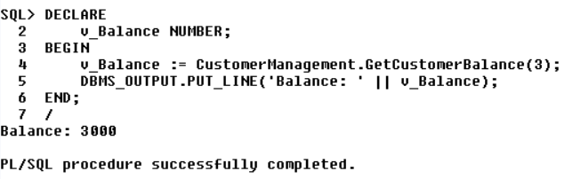

Scenario 2: Create a package to manage employee data.

**PL/SQL Code:**

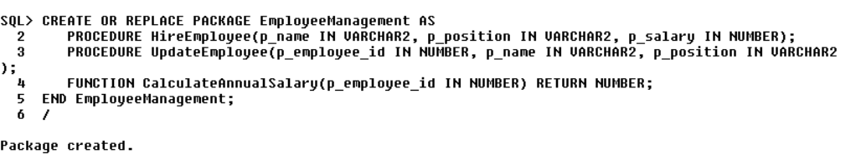

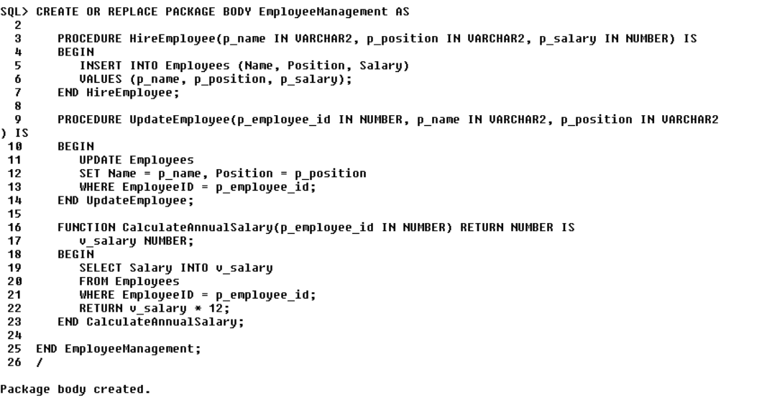

**Output:**

* HireEmployee()

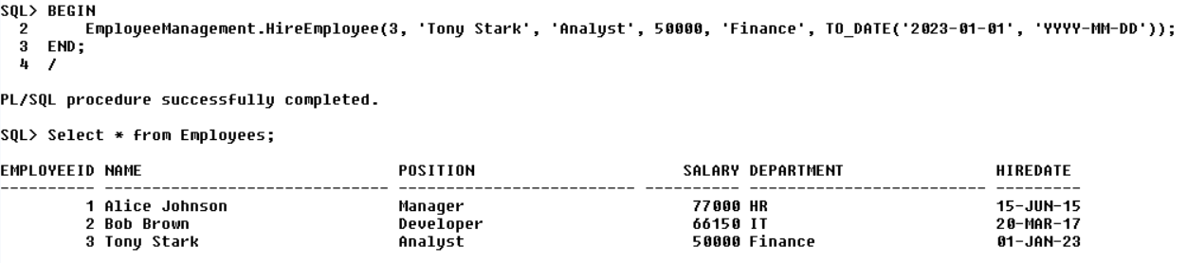

* UpdateEmployee()

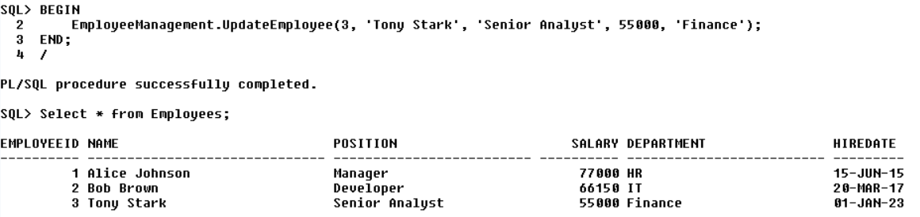

* CalculateAnnualSalary()

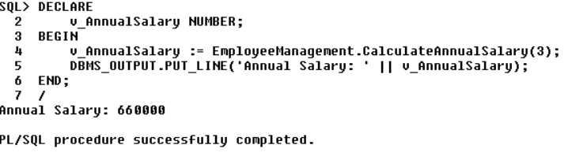

Scenario 3: Group all account-related operations into a package.

**PL/SQL Code:**

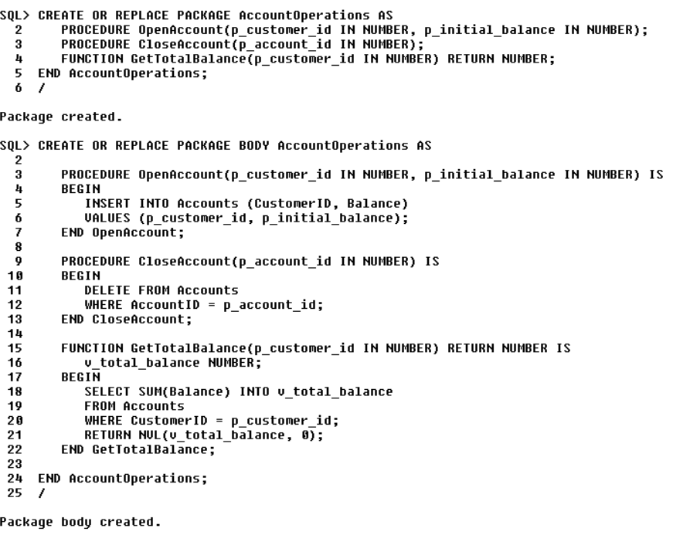

**Output:**

* OpenAccount()

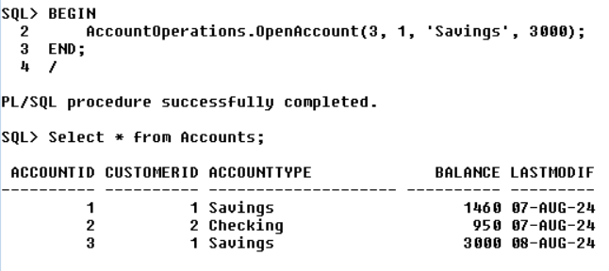

* CloseAccount()

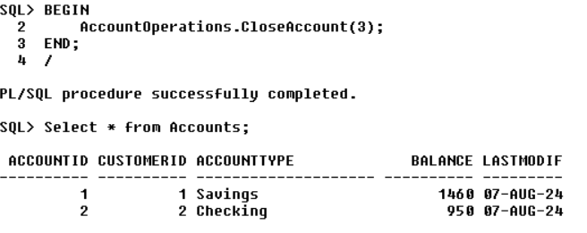

* GetTotalBalance()

